CCR Summer TT
Time Trials 2024
(Promoted for and on behalf of Cycling Time Trials under their rules and Regulations)
Summer 25-mile TT
9th June on the P884b/25 (A3)
The Headquarters are at the:
Greatham Village Hall, Greatham, GU33 6EU, HQ open from 6.30am

Timekeepers: Peter Delve & Neil Panter
Start Line Stewards: Nolan Rogers CCR & Nick Gates CCR
Marshals & Crew: Emma Hanon, Heather Wiltshire, Lily Wiltshire, Oliva Sloan, Ross Kettle, James Smee, Ryan Morgan, Alistair Sherlock
Results: Will be available during the morning http://www.resultsheet.co.uk/

WORKING FRONT AND REAR LIGHTS AND HELMET ARE NOW MANDORTARY TO COMPETE IN CTT EVENTS
Parking – Please use the car park at the Village Hall and overspill field, be aware this is a residential area & many will (sensibly!) still be in their beds so please keep the noise levels down, no noisy turbo’s please. Be aware this is a residential, no parking in the vicinity of Greatham Church.
Event Secretary: Larry Wiltshire, 28 Laxton Leaze, Waterlooville, Hants – 07889170893
Race day contact
Greatham hall: James Smee 07919560824 Or Larry Wiltshire 07889170893 email: Larry_wiltshire@hotmail.com
Procedure During the Event:
You Must Use a rear and front light & it must be switched on
If caught, ease back; do not take pace on the wheel of the rider who caught you If passing a rider please make sure the effort is enough to pass completely
Look where you are going, keep your head up & please don't hog the carriageway, keep to the inside lane at all times.

If you do have a mechanical, and some of know how long it takes to walk back from the furthest point on the course, please find a safe place to wait off the carriage way, as one of our starting Marshalls has offered to do a sweep of the course and collect trouble bodies, it would also be handy that if you get back to HQ and you have seen someone in this predicament to let one of the other HQ helpers know.

There will be tea and coffee after the ride and cakes that are being made by our CCR member, and any donations for the cake will go to the CCR charity of choice which is St Wilfred’s Hospice.

The preferred and safe route to the start: To ride to the Start: Turn Left upon leaving the HQ and allow at least five minutes getting to the Start. There is no need to go back & forth to the start as we do not move it once the event has started.

Please note there may be a Marshall stopping you at the top of the start ramp on the bridge to ensure we do not block the slip road completely

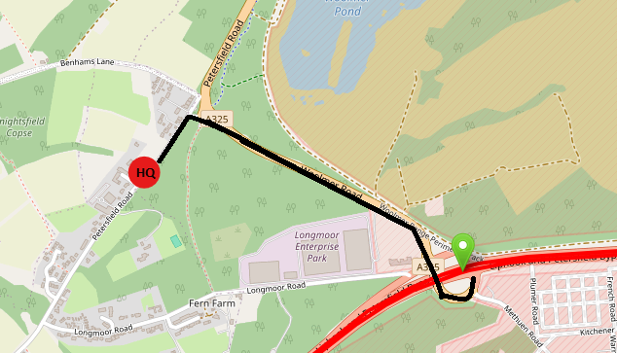

The preferred and safe route back to the HQ; After the finish proceed to Ham Barn roundabout and take the third exit, proceed along the B3006 to return to HQ and car park.
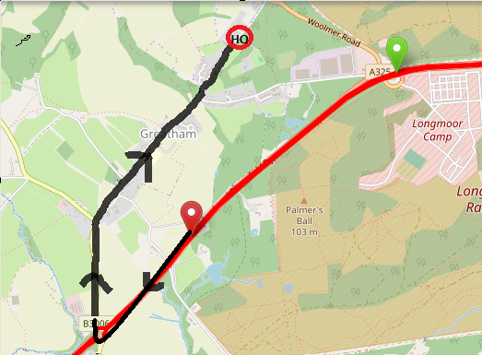

COURSE NUMBER: P884b/25
Distance: 25 miles ~ Short Description: Longmoor / Petersfield / Liphook / A3
Start on the Hard shoulder on the southbound slip road to the A3 at Longmoor (A325) three metres from the start of the Armco barrier. Proceed to the slip road onto the southbound A3 towards Petersfield'
At Ham Barn Roundabout (1.6m) take the second exit towards Petersfield, passing the exit for West Liss at 3.2m, the Midhurst exit (A272) and the Winchester (A272) and take the Buriton exit at 8.1miles.
Follow slip road and take first exit on roundabout (8.04 miles) to rejoin A3 north. Keep left here and take care to rejoin A3 towards London Guildford and continue along A3 passing exit for Winchester (A272) the Midhurst exit (A272) and the exit for West Liss, to Ham Barn Roundabout (15.1 miles).
Approaching Ham Barn Roundabout stay in the middle lane, take 2nd Exit and proceed North on A3 passing the exit slip road at Longmoor Interchange (signposted A325 Farnham), Griggs Green. At the third turning (20.1 miles) take the left turn signposted Haslemere/Liphook B2171, and continue over the flyover taking the left turn, over the flyover and next left onto the slip road to rejoin the A3 in a southerly direction (signposted Petersfield/Portsmouth).
Retrace along A3 southbound towards the Ham Barn Roundabout passing the Griggs Green turning (22 mile) and pass the starting area at Longmoor to finish at the entrance on the lay-by approximately 600 yards north of Ham Barn roundabout (25 miles).
Distance from Start to Finish 1.3miles ~ Headquarters will be at Greatham Village Hall

Please take care when joining the carriageway at Buriton and Liphook, also crossing the Main Ham Barn roundabout you must give way to traffic coming from the right and follow the highway code at all times

Start Area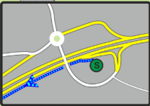
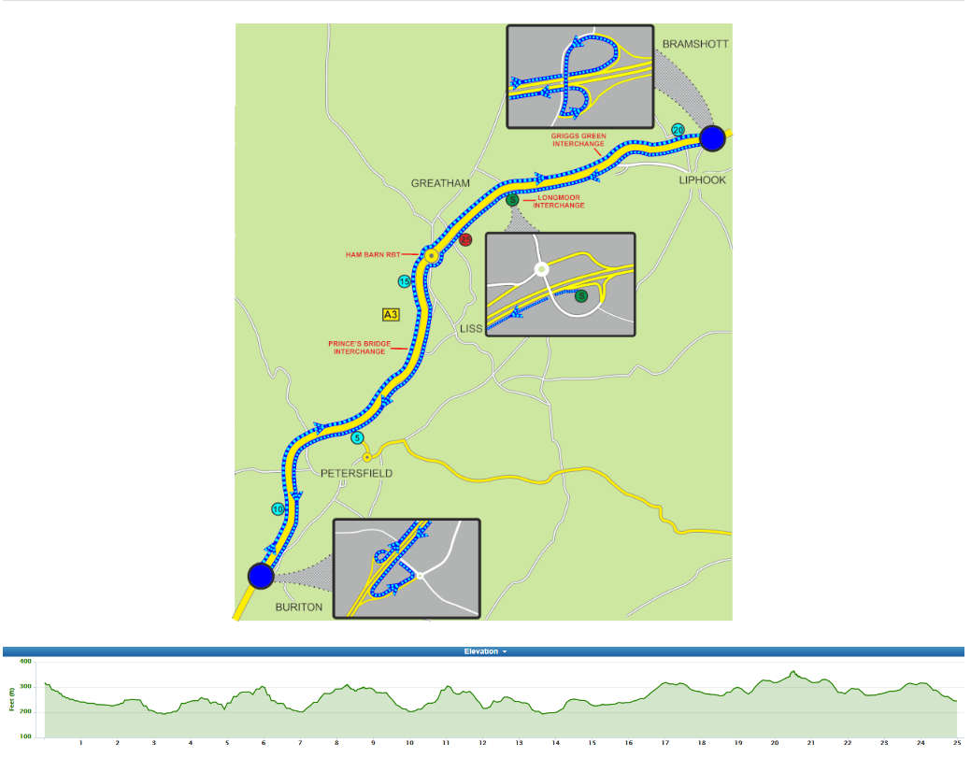
Buriton turn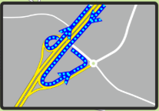
Liphook Turn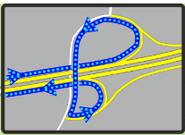
Prizes will be presented after the event, please stay & appauld the victors of the day. Prizes not collected will be deemed as donations to St-Wilfreds hospice the CCR charity of choice.
Prizes | 1st | 2nd | 3rd
Middle Marker Women’s Event | £20 | £15 | £5
Middle Marker Men’s Event | £20 | £15 | £5
Middle Marker Road Bike Event | £20 | £15 | £5
Scratch Women’s Event | £20 | £15
Scratch Open Men’s Event | £20 | £15 | £5

Course record according to spin data:
Female : Rachael Elliot 00:52:14 Male: Gary Chambers 00:46:58

bib | Start_time | Firstname | Lastname | machine | club | class | category
1 | 07:31:00 | Andrew | Lindsay | Road Bike | ...a3crg | Open | Senior
2 | 07:32:00 | Paul | Jones | TT Bike | Portsmouth North End CC | Open | Veteran
3 | 07:33:00 | Matt | Doe | TT Bike | ...a3crg | Open | Veteran
4 | 07:34:00 | David | Knight | TT Bike | Portsmouth North End CC | Open | Veteran
5 | 07:35:00 | Graham | White | TT Bike | Fareham Wheelers CC | Open | Veteran
6 | 07:36:00 | Chris | Summers | TT Bike | Sotonia CC | Open | Veteran
7 | 07:37:00 | Rachael | Lamont | TT Bike | Portsmouth North End CC | Female | Veteran
8 | 07:38:00 | Peter | Horsfield | TT Bike | Redmon CC | Open | Veteran
9 | 07:39:00 | Terry | Belbin | TT Bike | Poole Wheelers Cycling Club | Open | Veteran
10 | 07:40:00 | David | England | TT Bike | Crabwood Cycling Club | Open | Veteran
11 | 07:41:00 | Simon | Craig-McFeely | TT Bike | ...a3crg | Open | Veteran
12 | 07:42:00 | Nick | Pratt | TT Bike | Fareham Wheelers CC | Open | Senior
13 | 07:43:00 | Gary | Chiverton | TT Bike | Bournemouth Jubilee Whs | Open | Veteran
14 | 07:44:00 | Steve | Skinner | TT Bike | Southdown Velo | Open | Veteran
15 | 07:45:00 | Joe | Sanchez | TT Bike | Velo Clinic | Open | Senior
16 | 07:46:00 | Martin | Beale | TT Bike | Velo Club St Raphael | Open | Veteran
17 | 07:47:00 | Nick | Andrews | TT Bike | Portsmouth North End CC | Open | Veteran
18 | 07:48:00 | Vince | Freeman | TT Bike | Sussex Revolution Velo Club | Open | Veteran
19 | 07:49:00 | Mike | Boyce | TT Bike | ...a3crg | Open | Veteran
20 | 07:50:00 | Richard | Burchett | TT Bike | Crawley Wheelers | Open | Veteran
21 | 07:51:00 | Larry | Wiltshire | TT Bike | Chichester City Riders | Open | Veteran
22 | 07:52:00 | Ferenc | File | TT Bike | Horsham Cycling | Open | Senior
23 | 07:53:00 | Peter | Madarasz | TT Bike | Team TMC | Open | Veteran
24 | 07:54:00 | Stuart | Thompson | TT Bike | Velo Club St Raphael | Open | Veteran
25 | 07:55:00 | Liam | Kemp | TT Bike | Southampton Uni (SURC) | Open | Senior
26 | 07:56:00 | John | Mcdonald | TT Bike | trainSharp | Open | Veteran
27 | 07:57:00 | Dan | Shipton | TT Bike | Eastbourne Rovers CC | Open | Veteran
28 | 07:58:00 | Mark | Jones | TT Bike | GS Stella | Open | Veteran
29 | 07:59:00 | Rob | Vessey | TT Bike | ...a3crg | Open | Veteran
30 | 08:00:00 | James | Ayton | TT Bike | Portsmouth North End CC | Open | Veteran
31 | 08:01:00 | David | Pollard | TT Bike | VTTA (Surrey/ Sussex) | Open | Veteran
32 | 08:02:00 | Tony | Reeves | TT Bike | GS Stella | Open | Veteran
33 | 08:03:00 | Graham | Harman | TT Bike | Sotonia CC | Open | Veteran
34 | 08:04:00 | Chris | Lord | TT Bike | Brighton Excelsior CC | Open | Veteran
35 | 08:05:00 | Scott | Leeson | Road Bike | Onyx RT | Open | Senior
36 | 08:06:00 | Richard | Tully | TT Bike | Elite Cycling | Open | Veteran
37 | 08:07:00 | Paul | Tippett | TT Bike | Destination Bike RT | Open | Veteran
38 | 08:08:00 | Simon | Berogna | TT Bike | Velo Club St Raphael | Open | Veteran
39 | 08:09:00 | Anita | Turner | TT Bike | Eastbourne Rovers CC | Female | Veteran
40 | 08:10:00 | Richard | Llewellyn | TT Bike | Imperial Racing Team | Open | Veteran
41 | 08:11:00 | Brett | Wheeler | Road Bike | Poole Wheelers Cycling Club | Open | Senior
42 | 08:12:00 | Ben | Schooling | TT Bike | Chichester City Riders | Open | Veteran
43 | 08:13:00 | William | Sawyer | TT Bike | Velo Club St Raphael | Open | Veteran
44 | 08:14:00 | Adam | Rogers | TT Bike | Eastbourne Rovers CC | Open | Veteran
45 | 08:15:00 | Adam | Coppard | Road Bike | Chichester City Riders | Open | Senior
46 | 08:16:00 | Adrian | Talley | TT Bike | Velo Club St Raphael | Open | Veteran
47 | 08:17:00 | Steven | Pink | TT Bike | Poole Wheelers Cycling Club | Open | Veteran
48 | 08:18:00 | Keith | Lea | TT Bike | Paceline RT | Open | Veteran
49 | 08:19:00 | Andrew | Rivett | TT Bike | Velo Club St Raphael | Open | Veteran
50 | 08:20:00 | Aaron | Borrill | TT Bike | Farnborough&Camberley CC | Open | Veteran
51 | 08:21:00 | Peter | Main | TT Bike | 34 Nomads CC | Open | Veteran
52 | 08:22:00 | Howard | Shaw | TT Bike | trainSharp | Open | Senior
bib | Start_time | Firstname | Lastname | machine | club | class | category
53 | 08:23:00 | Nick | Dwyer | TT Bike | DRAG2ZERO | Open | Veteran
54 | 08:24:00 | Neil | Mackley | TT Bike | ...a3crg | Open | Veteran
55 | 08:25:00 | Paul | Burton | TT Bike | Paceline RT | Open | Veteran
56 | 08:26:00 | Peter | Allan | TT Bike | Team Velo Sportif | Open | Veteran
57 | 08:27:00 | Howard | Bayley | TT Bike | ...a3crg | Open | Veteran
58 | 08:28:00 | Pat | Wright | TT Bike | Paceline RT | Open | Senior
59 | 08:29:00 | Liam | Maybank | TT Bike | Twickenham CC | Open | Veteran
60 | 08:30:00 | Samuel | Wadsley | TT Bike | Poole Wheelers Cycling Club | Open | Senior

